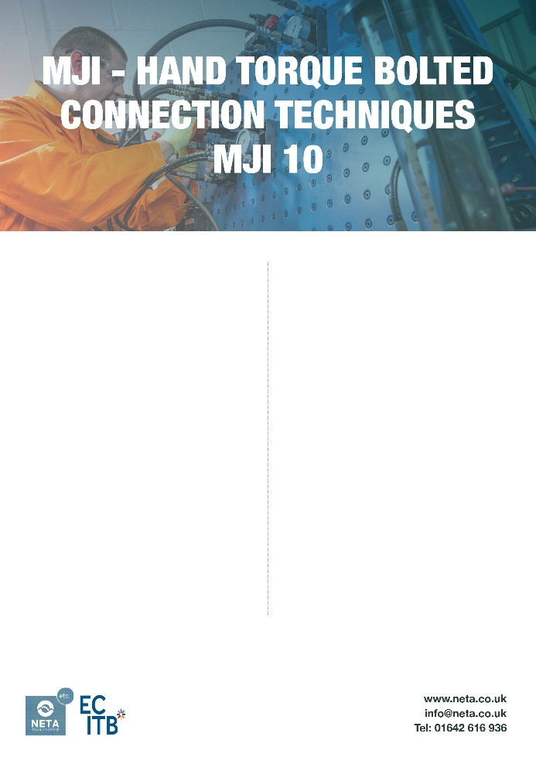

Course Overview
This course provides delegates with the knowledge and practical skills required to safely dismantle, inspect, prepare, assemble, and tighten bolted flange connections using hand torque methods. The training follows industry standards and best practices to reduce the risk of hydrocarbon releases and ensure safe operations in oil, gas, power, and process industries

Duration & Maximum Numbers
- 1 Day
- 6 Delegates

Who Should Attend
- Mechanical technicians, fitters, and maintenance personnel involved in assembly or disassembly of bolted connections
- Supervisors and inspectors responsible for verifying flange joint integrity
- Contractors and staff working in oil and gas, petrochemical, power generation, and related process industries

Entry Requirements
- Basic mechanical knowledge and experience in engineering or maintenance.
- An understanding of workplace safety practices.
- Appropriate PPE required for the practical elements.

Key Benefits
- Industry-recognised certification
- Improves safety and reduces downtime
- Hands-on, practical training
- Enhances employability and compliance
Course Content
- Introduction to Mechanical Joint Integrity and industry safety standards
- Flange joint components and gasket awareness
- Tool selection and safe use
- Joint preparation and controlled tightening
- Dismantling and inspection procedures
- Identification and rectification of common flange connection faults
- Practical workshop exercises

Assessment & Certification
- Assessment: Combination of practical demonstrations and written knowledge tests.
- Certification: Delegates who successfully complete the course and pass the assessment will receive an ECITB certificate of achievement for MJI10.

Additional Information
Our staff place the utmost importance on meeting the needs and expectations of our service users. If you have any concerns or would like to share feedback about the service, please contact: quality@NETA.co.uk

Course Ref: CPM06/V1/0925

