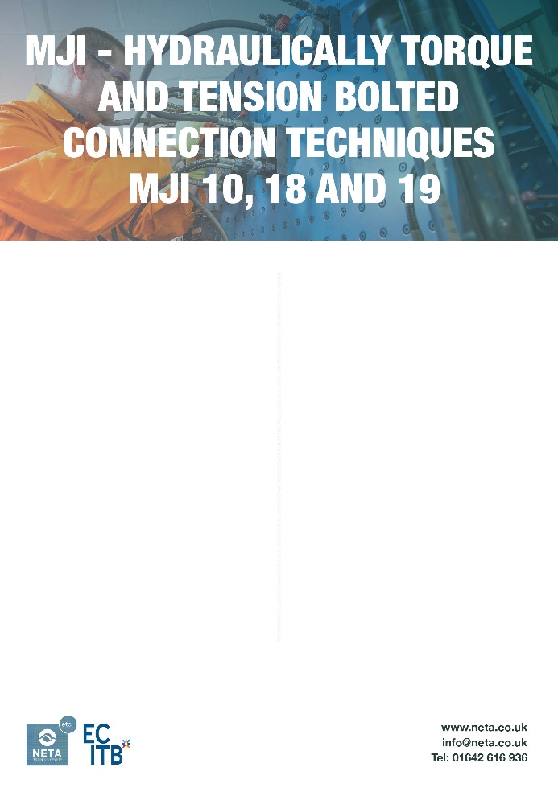

Course Overview
The aim of this course is to focus delegates on Mechanical Joint Integrity and the adoption of best practice in ensuring a leak-free ‘right first time’ joint. The course covers hand torquing, hydraulic torquing, and hydraulic tensioning bolted connection techniques in accordance with the latest ECITB training standards.

Duration & Maximum Numbers
- 3 Days
- 4 Delegates

Who Should Attend
- Bolting technicians, pipefitters, maintenance, mechanical technicians and engineers
- Supervisors or inspectors who need to understand torque, tension, bolted joint integrity
- Anyone whose work involves critical bolting (e.g. oil and gas, chemical, power, renewable energy, process) where joint integrity is essential to safety and performance

Entry Requirements
- An understanding of workplace safety practices
- PPE required for the practical elements
- Must have completed MJI-01 First Principles

Key Benefits
- Ensures personnel are trained to industry recognised standard
- Practical, hands-on training with real equipment
- Improves safety, reliability and employability
- Builds confidence in critical bolted joint work
Course Content
- Health and Safety in Bolted Assembly / Disassembly
- Principles of Bolting, Flanges, Mechanical Seals, Industrial Fasteners, Compact Flanges, Hub and Clamp Pipe Connections and Torque Tightening
- Alternatives to Torque
- Flange Joint Assembly Techniques
- Bolted Joint Assembly using Manual Torque Equipment, Hydraulic Torque Wrenches and Bolt Tensioning Equipment

Assessment & Certification
- Knowledge Test
- Practical Observation: Demonstration of safe working practices and correct assembly techniques for hand torquing, hydraulic torquing, and hydraulic tensioning.
- Certification: ECITB Certificate of Training in MJI-10 (Hand Torque), MJI-18 (Hydraulic Tension) and MJI-19 (Hydraulic Torque).

Please Note: This certificate confirms training but does not demonstrate competence. Competence is verified through the successful completion of the TMJI technical tests.

Course Options
- Stage 1 – Training (in-centre delivery)
- Stage 2 – Workplace Practice (3 to 12-month consolidation period inc. Work Based Task)
- Stage 3 – Technical Tests (TMJI10, TMJI18, TMI19) to verify competence

Additional Information
Our staff place the utmost importance on meeting the needs and expectations of our service users. If you have any concerns or would like to share feedback about the service, please contact: quality@NETA.co.uk

Course Ref: CPM09/V1/0925

